**Q.1-Enumerate 5 for each of the followings: 20 Marks**

**1- Symptoms of symptomatic type of** **irreversible pulpitis**

**2- Indications of apicectomy and root curettage**

**Q.2-Answer in true or false 30 Marks**

**1-Vertical root fracture can be treated by endodontics**

**2-The pain in reversible pulpitis is continue even after removal of stimulus**

**3-In working length determination, good electronic apex locators can determind the apical constriction**

**4-The cutting efficiency of endodontic file is less than reamer**

**5-The distal pulp horns are usually higher than the mesial pulp horns**

**6-The lateral canal that is located approximately right angles to that of the main canal extending from the main canal to the periodontal ligament**

**7-Conventional burs are used successfully for access opening preperation**

**8-Young patient has lerger pulp chamber than old one**

**9-Cervical widening (Coronal preflaring) improve the working length determination**

**10-We can use electronic apex locator successfully in case of open apex and amalgam restoration**

**Q.3-Fill in the blanks: 30 Marks**

**1- The best materials for direct pulp capping are ----------------and--------------**

**2- The instrument used for lateral condensation of gutta-perccha is named----------------.**

**3- The instrument used for vertical condensation of gutta-perccha is named as ---------------.**

**4-Pulp space becomes smaller from deposition of ------------------ and ------------ dentin**

**5-The canal that branches off from the main root canal usually somewhere in the apical region of the root are called --------------**

**6-The narrowest portion at the terminal end of the pulp space called -------------**

**7-The best magnification for access opening to locate the canals is ---------------which my reach to X25 magnification**

**8-The main apical opening of the root canal is called --------------------**

**Q.4- Answer the followings 20 Marks**

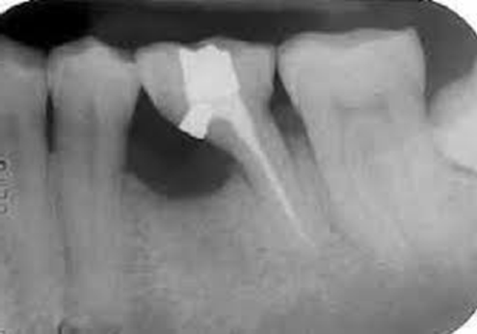

**1-What is the name of procedure?**



**2-What is the name of procedure?**

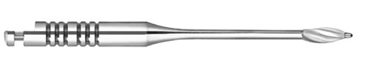

**3-What is the name of bure?**

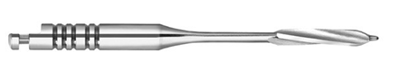

**4-What is the name of bure?**

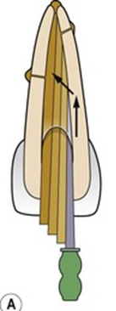

**5-What is the name of instrument?**

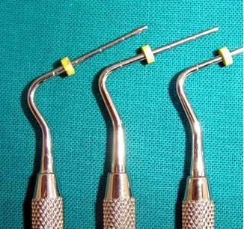

**6-What is the name of procedure?**

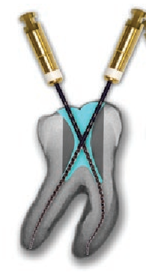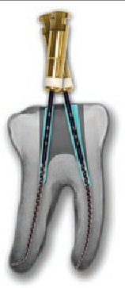

**7-Which one is correct access opening?**

**Why?**

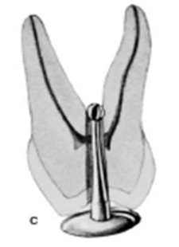

8-Which type of error in access cavity?