**Q 1- Answer in true or false 30 Marks**

1. Fiber post is more dangerous than threaded metal post.
2. Cold lateral condensation is better sealing ability than warm vertical condensation.
3. Calcium hydroxide my arrest external root resorption and accelerate healing.
4. The endodontic sealer should set quickly.
5. Ferrule is protecting the crown from vertical fracture
6. MTA based sealer is highly sensitive to moisture and blood (hydrophilic)
7. Bisecting angle, radiographic technique in endodontic is better than parallel one.
8. The access cavity of upper premolar is oval shape mesio-distally
9. At least 4 to 5 mm of gutta-percha should be left in the apical portion of the canal to ensure an adequate seal.
10. The access cavity out line of maxillary first molars are triangle in shape the apex is distally, and the base is mesially.
11. Inadequate irrigation cause accumulation of debris inside the canal and lead to obstruction.
12. It is possible to use electronic apex locator properly with amalgam or metal restoration.
13. When we use small file size (6,8,18) it is better to choose NiTi metal.
14. Extension of instrumentation to the apical constriction increase the possibility of post-operative pain.
15. It is better to use resin sealer if we have a case of root canal treatment of a tooth with apex near to the vital structures like maxillary sinus or inferior dental nerve.

**Q 2- Answer the followings: 40 Marks**

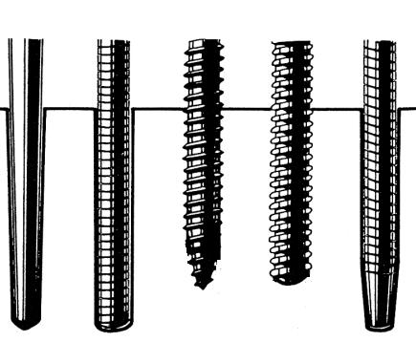

1-Which type of posts in figure?

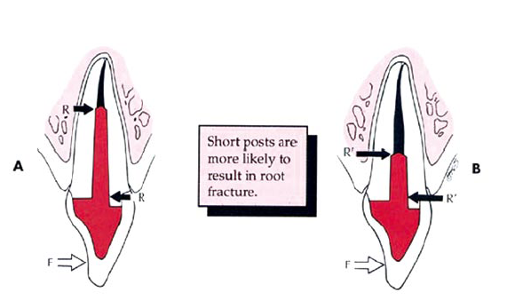

2-What happened in A & B



3-Name of instrument

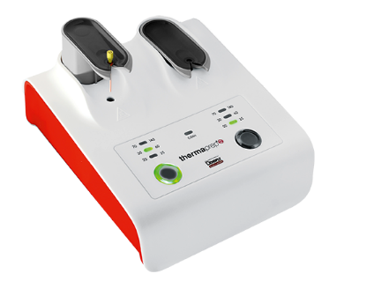

4-Name of the device

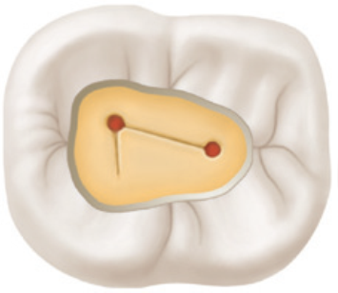

5-Which type of error?

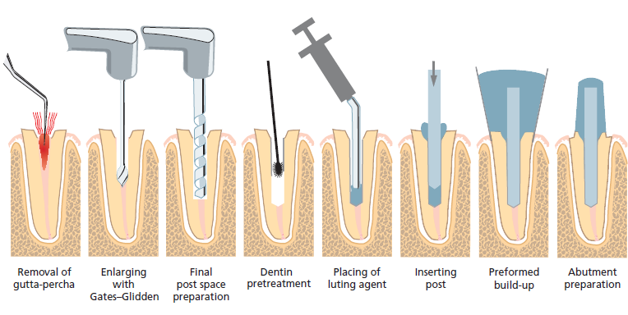

6-What does this figure explain?

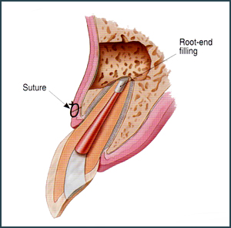

7-Name the type of endodontic surgery

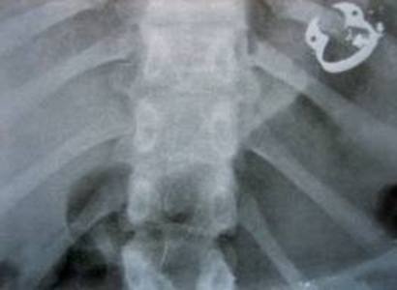

8-What dose happened in this chest radiograph?

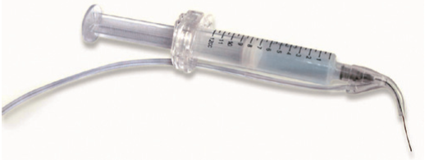

9-What is the device?

For what is used?



10-What are the differences between the left one bur and the 3 Right side?

Uses of both

**Q 3- Answer the followings 30 marks**

1. Innumerate 5 methods of Gingival management
2. Disadvantages of composite as a buildup material, 5 only
3. Innumerate the factors affecting the quality of obturation, 5 only
4. Define clarke’s rule in endodontic radiography
5. Innumerate 5 points to prevention of ledge formation
6. Causes of NaOCL accident, 5 only